|  |  |
| --- | --- |
| **HTTP 1.1** | **HTTP 2.0** |
| * **Low Performance** * **Get and Post Method One by One work** * **Slow Loading Speed** * **Broadband Consumption High** * **Data Consumption High** * **Slowly Downloading** * **More connection** * **Header Text Format** * **Server push Not supported** * **TLS Encryption Extra Latency** * **Inefficient use of network resources.** | * **High Performance** * **Get and Post Method Parallel work** * **Fast Loading Speed** * **Broadband Consumption Low** * **Data Consumption Low** * **Fast Downloading** * **Multiple request ,response -single TCP Connection** * **Header Binary Format** * **Server push Support** * **TLS Encryption minimal latency** * **Optimized Network usage** |

**Question No:1**

**Javascript Object**

**Question No:2**

**Introduction**

**In JavaScript, objects are fundamental data structures that allow developers to represent and manipulate complex data.**

**You Can store Some Information inside of the two curly braces its called Javascript Object.**

**The Basics of Objects**

**In JavaScript, objects are collections of key-value pairs. These key-value pairs are called properties, where the keys are strings and the values can be of any data type, including other objects. Objects provide a way to structure data, organize functionality, and model real-world entities.**

**Javascript Object:**

* **You can Store a Object inside of the Object.**
* **Javascript is Two Type of object referes,**

1. **Dot notation= . console.log(student.name)**
2. **Bracket Notation= [] ,****console.log(student[‘name’])**

**simple example of an Javascript object:**

**let student = {**

**name: “Dinesh”,**

**email: “dinesh123@gmail.com”,**

**subject: {**

**html: 100,**

**css: 99,**

**javascript:95,**

**}}**

**Internal Representation of Objects**

**Under the hood, JavaScript engines use various data structures to represent objects efficiently. While the exact implementation details may vary between JavaScript engines (like V8 in Chrome, SpiderMonkey in Firefox, and JavaScriptCore in Safari).**

**Conclusion**

**Understanding the internal representation of objects in JavaScript is crucial for writing efficient and maintainable code. Objects are versatile and powerful data structures that form the basis of many JavaScript applications. Whether you're building web applications, working with JSON data, or implementing complex algorithms, a solid grasp of objects and their internals is essential for becoming a proficient JavaScript developer.**

**Question NO:3 20/9/2023**

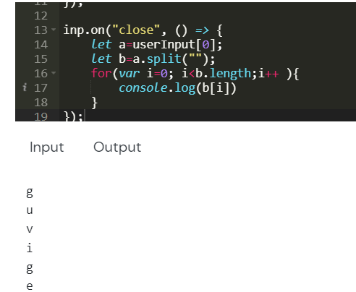

**Question No:4**

Ip address  192.168.123.132 , Mac Address: 00-B0-D0-63-C2-26.

Port:5000 ,,HTTP Methods Get,Post,Put,delete